TEAM4OARS

Step by Step Tutorial on How to Create our TEAM PROJECT WEB APPLICATION

Version 1.0

Signature Block

COSC 4351 | Name Signature | Date
SE Team Leader
SE SQA
Our TEAM4OARS is using the following technologies:

ASP.Net MVC using C#.
JavaScript, AJAX and SQL
IDE: Visual Studio 2015
DBMS: Microsoft SQL Server

These are the steps to create the TEAM4OARS web site

- Download and Install Visual Studio Community 2015
  - Visual Studio Community 2015 - https://www.visualstudio.com/en-us/downloads/download-visual-studio-vs.aspx

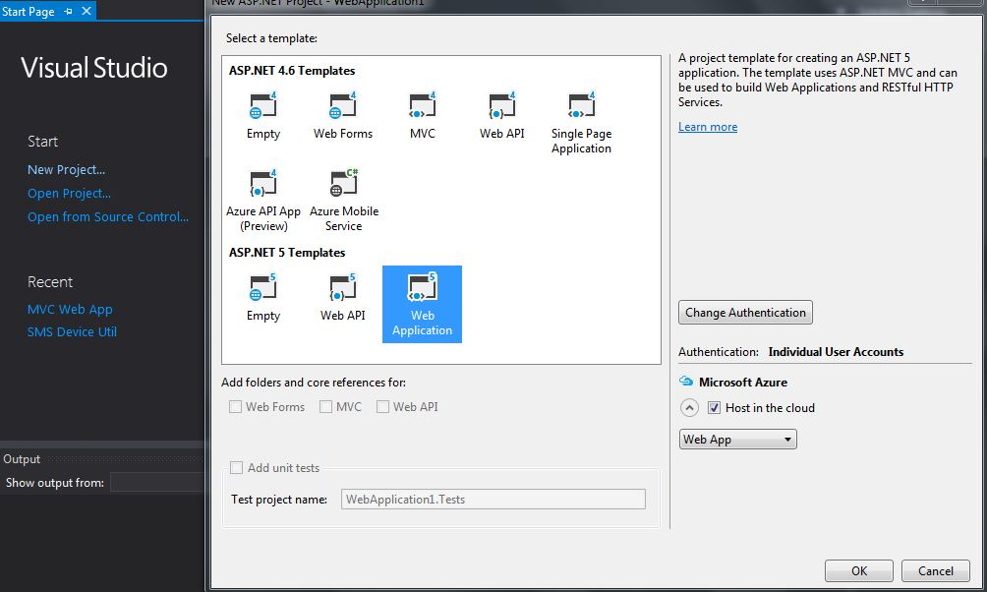
- After Visual Studio has been installed, create a new project and call it “TEAM4OARS”, the select the ASP.Net 5 Web Application Template and click Ok

- Once the project is created, open the view _Layout.cshtml and modify the following lines
<div class="navbar-collapse collapse">
<ul class="nav navbar-nav">
<li><a asp-controller="Home" asp-action="Index">Home</a></li>
<li><a asp-controller="Home" asp-action="About">About</a></li>
<li><a asp-controller="Home" asp-action="Testimonials">Testimonials</a></li>
</ul>
@await Html.PartialAsync("_LoginPartial")
</div>

- Open Controllers/HomeController.cs and add the following lines
public IActionResult Testimonials()
{
ViewData["Message"] = "Search Testimonials";

return View();
}

- Go Views/Home and Create a new MVC View Page by right clicking and selecting add new item. Name it “Testimonials.cshtml”
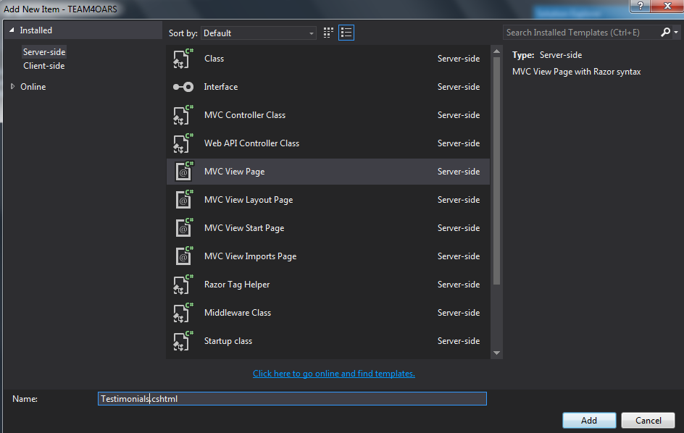
Then open and delete the contents of the new file and add the following lines
@{
ViewData["Title"] = "Testimonials";
}
<h2>@ViewData["Title"].</h2>
<h3>@ViewData["Message"]</h3>
<input id="searchT" type="text" /><input id="searchBtn" type="button" value="Search" />

- Open Views/Home/About.cshtml and a modify the <p> tag with the following
<p>This page will provide information about TEAM4OARS and its history.</p>
- Open Controllers/HomeController.cs and modify the following section
public IActionResult About()
{
ViewData["Message"] = "TEAM4OARS History.";

return View();
}
- The initial Design of the Web Application has been created just run and test it

Document Control
Change History

Table 1: TLs entries (assigned work and due dates) before releasing to the team
Revision | Name | Due Date | Description
1.1 | TM Joshua Wilburn | 02/18/2106 | Work on Step by Step instructions
1.1 | TL Bertol Salgado | 02/18/2016 | Review Document and make changes as needed and add project to SVN

Table 2: Entries when work completed (SVN Commit Comment matches Description)
Revision | Name | Completed Date | Description
1.2 | TM Joshua Wilburn | 02/20/2016 | Completed First draft of Step by Step Instructions
1.B | TL Bertol Salgado | 02/21/2016 | Reviewed Document and changed instructions to work with ASP.NET MVC 5 and to start by downloading VS2015

Table 3: TL entry for RED DELIVERABLES (SVN Commit Comment matches Description)
Revision | Name | Due Date | Description
2.0 | TL & Name | XX/XX/XXXX | I changed Version to 2.0

Document Storage
This file is stored in SVN at https://svn.cs.uh.edu/svn/cosc4351/team4/TEAM PROJECT DELIVERABLES/Step by Step Tutorial on How to Create our TEAM PROJECT WEB APPLICATION.doc.

